RESUME OF
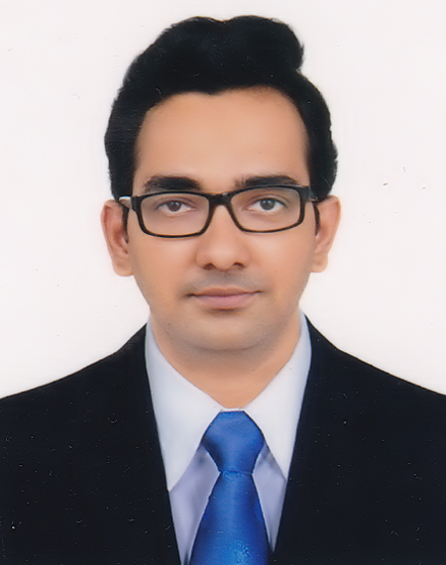

Tuhin Biswas

B. Sc. in Civil Engineering
Khulna University of Engineering and Technology (KUET)
Khulna-9203, Bangladesh
Cell Phone: +8801717298410

E-mail: tuhinkuet99@gmail.com

Career Objectives:

- To work in a friendly environment where I can work instinctly and independently. To earn a job that provides me job satisfaction and gives me social security namely provident fund, gratuity and other facilities.

- To give the best output in the esteemed organization that provides me social security. To build an innovative career in that organization by using my skills, talents and devotion.

- To excel in my field through hard work and to maintain a good work-life balance. To serve my parents, and my country with the best of my abilities.

Special Qualification:

I have done a course on R.C.C tall building design using ETAB.

Computer Proficiency:

Operating System | Windows 2007, Windows 2010
Package | Microsoft Office (Word, Excel, PowerPoint)
Civil Software | Auto CAD, ETABS
Others/OS | Browsing of Internet

Personal Information:

Name: Tuhin Biswas | Marital Status: Single
Father’s Name: Biswanath Biswas | Nationality: Bangladeshi
Mother’s Name: Marry Biswas | Smart NID No. : 5992603380
Date of Birth: 15-01-1990
Gender: Male
Religion: Sanatan | IEB Membership No.: M-38225
Present Address: Anderkilla,  17, Ghatforhadbeg,  Monindro Majhir Pahar | Permanent Address: Anderkilla,  17, Ghatforhadbeg,  Monindro Majhir Pahar
Post: GPO,4000 | Post: GPO,4000
Thana: Kotwali | Thana: Kotwali
District: Chattogram, Bangladesh | District: Chattogram, Bangladesh

Educational Qualification:

Criteria | Major | Institution | Year of Passing | CGPA
B.Sc.  Engineering | Civil  Engineering | Khulna University of  Engineering & Technology | 2014 | 2.88 (out of 4.00)
H.S.C | Science | Chittagong College | 2008 | 4.90 (out of 5.00)
S.S.C | Science | Chittagong Collegiate School | 2006 | 5.00 (out of 5.00)

Project Title:

“Water-Stage Forecasting in a Multi-Tributary Tidal River Using a Bidirectional
Muskingum Method”

Supervised by: Prof. Dr. Kh. Md. Shafiul Islam, Department of Civil Engineering,
Khulna University of Engineering & Technology (KUET), Khulna9203, Bangladesh

Thesis Title:

“Stabilization of Organic Soils with Fly Ash”

Supervised by: Prof. Dr. Md. Abul Bashar, Department of Civil Engineering,
Khulna University of Engineering & Technology (KUET), Khulna9203, Bangladesh

Language of Communication:

- Good communication Skill over English. (Written, Reading& Spoken)

- Fluent in Bengali literature & Composition (Native Language)

Personal Attributes:

- I am self-confident & being positive

- Capable to manage time & to be flexible.

- Capable to work efficiently under pressure & fulfill deadlines.

- My greatest strength is that I am so much responsible. That’s why company can rely on me.

- Capable to work independently but I can give my best effort if I get proper guidelines.

- I am open mined in adapting to new & challenging situation.

- Capable to work in teams & maintain effective communication. (Both oral & written)
- I have experiences of management after arranging cultural function in my university.
- My greatest weakness is that I can’t say “NO” but I think I can overcome it through my profession.
- I organized a study tour in my department which includes almost sixty students and handled them efficiently for near about 10 days
International Conference Paper Publication:

I have an international conference paper publication on the topic named “Study on Stabilization of Organic Soils with Fly Ash” in the 3rd International Conference on Civil Engineering for Sustainable Development. (ISBN-978-984-34-0264-6)

Reference

Dr. Md. Abul Bashar Dr. Muhammed Alamgir
Ex-Professor Ex-Vice Chancellor & Professor

Department of Civil Engineering Department of Civil Engineering
Khulna University of Engineering & Khulna University of Engineering Technology, Khulna - 9203 Technology, Khulna - 9203
Mobile: +8801714087298 Mobile: +8801714087277
E-mail: basharkuet@yahoo.com E-mail: alamgir63dr@yahoo.com

Certification:

I, the undersigned, certify that to the best of my knowledge and belief, these data correctly describe my qualification and me.

Date: 24/ 07 / 2021 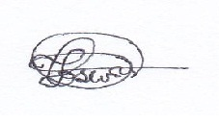
(Signature)

