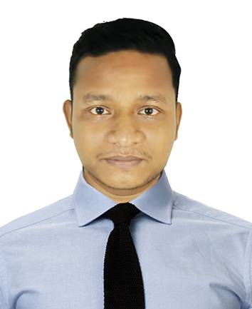**CURRICULUM VITAE /RESUME**

**OF**

**SHIBRAJ SHIL.**

Career Objective: *To have a challenging career, where into perform, accomplish and excel responsibilities, hence be contributing growth and betterment of the work, the company and personal self. Evaluated by peers and seniors as a hardworking, reliable and dynamic self-starter with a very positive attitude and as eloquent as persuasive negotiators.*

**Educational Backgrounds:**

**B. Sc. in Civil Engineering**

CGPA : 3.10 OUT OF 4.00

Department : Civil Engineering

University : Port city international university.

Passing year : 2018

**Diploma in Architecture.**

CGPA : 3.26 out of 4.00.

Department : Architecture.

Institute : National Polytechnic College.

Passing year : 2014.

Board : Bangladesh Technical Education Board.

**Secondary School Certificate**

GPA : 4.30 out of 5.00

Department : Drafting Mechanical.

Institute : Technical Training Centre, Chattogram.

Passing year : 2009

Board : Bangladesh Technical Education Board.

**Computer Literacy:**

**Good Skill of Auto CAD 2D, 3ds Max ,vray, Lumion, skecthup, Photoshop & Microsoft Office Programme.**

**Communication Skill:**

**Good Communication Bangla & English.**

**Experience:**

**i.** I have been worked in **‘’Design point’’** (consulting firm) as a assistant Engineer in the Engineering Department from June 2014 to July 2016.

**ii.** I have been worked in **‘’XID Architect’’** (consulting firm) as a assistant Engineer in the Engineering Department from August 2016 to August 2018.

**iii.** I have been worked in **‘Design Drive’’** (consulting firm) as a assistant Engineer in the Civil Department from August 2018 to runing.

**PERSONAL INFORMATION**

**Name : Shibraj Shil.**

**Father’s Name : Purnendu bikash shil.**

**Mother’s Name : Basanti rani shil**

**Present Address : Vill:-South quaish**

**P.O: Nur-ali bari.**

**P.S: Hathazari, Chittagong**

**Permanent Address : Vill:-South quaiah,**

**P.O: Nur-ali bari.**

**P.S: Hathazari,** **Chattogram.**

**Mailing Address : S.A international, Board school, Chandgaon,** **Chattogram.**

**E-mail Address : Devraj.shil@gmail.com**

**Marital Status : Unmarried**

**Date of birth : 12/06/1993.**

**Religion : Hindu.**

**Nationality : Bangladeshi by birth**

**Phone : 0196-5649744/0151-6179600**

**________________________________**

**Shibraj Shil**