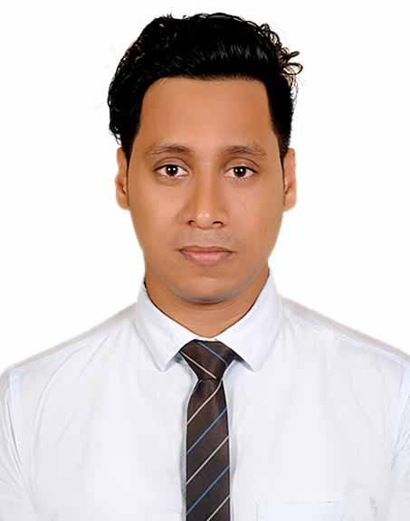
Resume Of
SAYKAT CHOWDHURY SHAWON
Studying MBA in Accounting & Compliance,
Marketing Officer of Chevron Clinical Laboratory (Pvt.) Ltd.
MS. Office and English & Bangla Typing Specialist.
Tally Accounting, Inventory & Payroll Management Software Operator.
C/O- Samar Chowdhury. (Present Address)
House No-755, Garden Enclave, Jhawtola, Momin Road.
P.S- Kotwali, Dist.- Chattogram. Cell- 01311818610 / W-01815358189
Email: saykatshawon@gmail.com

Works Experience :
- Presently I am Employee of Chevron Clinical Laboratory (Pvt.) Ltd. As a Marketing Officer where responsibility of clinical laboratory develop & representative of company. Joining 15/03/21 To Yet.
- MarkPro Solution, Authorized Tally Partner, Accounting Software Distributer Company, Joined 16/07/2018 to 28/02/21 As a Commercial Officer, where my responsibility Market Visit & Develop, Customer Service & Accounts Data Solution of Software.
- CCK City Network Inc.,Chattogram,Bangladesh.As a Assit. Accounts and HR Compliance Officer, CCK City Network Inc. is a Japanese Multi National IT Company. Since 2014 to 1/07/2018.
- Having also experienced on Sales-Marketing & Assistance managing of `Sristy’ Boutiques Showroom since 2009 to 2013.

Certificate Course And Training:
- Certificate Course on “Tally” Accounting, Inventory & Payroll Management Software Operating Procedure from Markpro Solution (Integrated IT Solution Pro).
- Certificate Course on Fire Safety & Compliance from Institute of Apparel Management (IAM) under Skill for Employment Investment Program (SEIP) of Ministry of Finance and BGMEA.

ACADEMIC QUALIFICATION:

Masters of Business Administration (MBA in Accounting)
Govt. Commerce College,Chattogram. (National University)
Pending Due to Covid’19
Bachelor of Business Studies (BBS)
Omorgani M.E.S College, Chattogram. (National University)
Result: 2nd Division, Passing Year: 2015

Higher Secondary School Certificate (H.S.C)
Business Studies, K.C. Shahid Ziaur Rahman College (Chattogram Board)
Passing Year: 2011, G.P.A : 2.90

Secondary School Certificate (SSC)
Business Studies, Charkhanay High School, Patiya (Chattogram Board)
Passing Year: 2009, G.P.A : 2.88

computer Literacy:
**Operating System: Windows 10 and both typing English & Bangla (Speed: 35/20)
**Software Application: MS Office Suite (Word, Excel, PowerPoint) & Tally Software.

PERSONAL STRENGTHS:
- Possess superior interpersonal, oral, and writing skills.
Capable to work under immense pressure and in a challenging work environment.
- Have strong leadership capabilities, and a very good team player. Self-Motivated and Flexible with an ability to adapt to changing environments.
- Capable to drive motor bike with licenses & Playing Guitar.

Interests:
Driving, Traveling, Watching movies and documentaries, Playing Guitar & Listening to Music.

Lingual Fluency:
Bengali: Fluent in reading, writing and speaking (devoid of local accent).
English : Fluent in reading, writing and speaking.

Personal Profile:
Father's name : Samar Chowdhury
Mother's name : Jinu Chowdhury
Date of birth : 18/08/1991
Permanent Address : Vill: Panchuriya,Post:Hulain-4367,P.S:Patiya, Dist: Chattogram. Marital Status : Single(Unmarried)
Religion : Buddhist
Nationality : Bangladeshi (By Birth)
Blood group : O+ (ve)
Height : 5'.4''

Reference:
Dr. Ashim Kumar Chowdhury  M.B.B.S, DDV (BSMMU) ABLS (USA), PGT (Medicine & Nephrology) CMCH.  Cell:01717936337  Email: ashimcho1980@gmail.com  Relation: Adviser | Prof. Sushen Barua  Professor, Department Of Accounting.  Govt. College of Commerce, Chattogram.  Cell : 01818-691011  Email : sushen2020@gmail.com  Relation : Departmental Teacher
DECLARATION:
I am Saykat Chowdhury, hereby declare that all the information reveled above is true.
Authenticated by

Saykat Chowdhury

